EECS 2311

VENN DIAGRAM APPLICATION

User Manual

**By:** Mahamed Hassan - 216536476

Derui Liu - 215608946

Thanh Nguyen - 213507231

Esra Kastrati - 215507205

**Group 10**

**User Manual**

**How to get started:**

Java 8 or above is required to run this program. You can download it here: <https://www.java.com/en/download/>

To run the program, double click the .JAR file. If that doesn't work, open a terminal in the same directory of the .JAR file. Then enter “java -jar venn.jar” or the current name of the .JAR file if it has been renamed.

The program will open and you are now ready to add your data to the Venn diagram. Currently, there is no way to save the Venn diagram beyond taking a screenshot of the program.

1. By selecting the left set, you can now add to that set by typing in the textbox below and clicking ‘Add’
2. By selecting the middle where both sets intersect, you can now add to it by typing in the textbox below and clicking ‘Add’.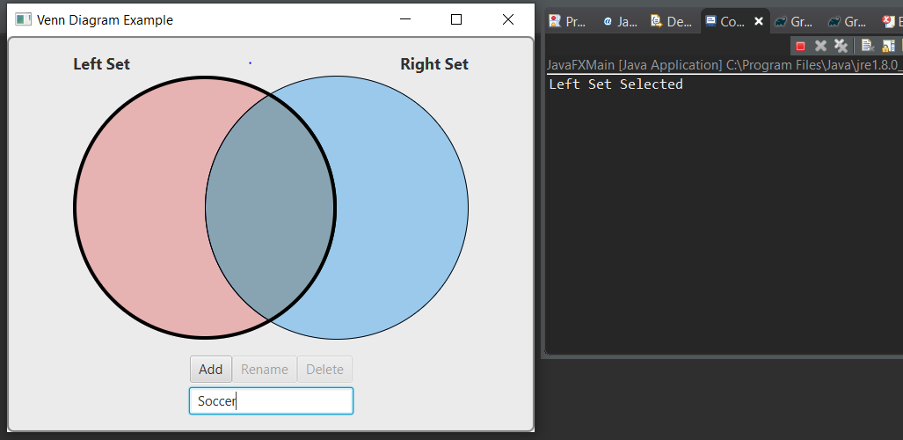

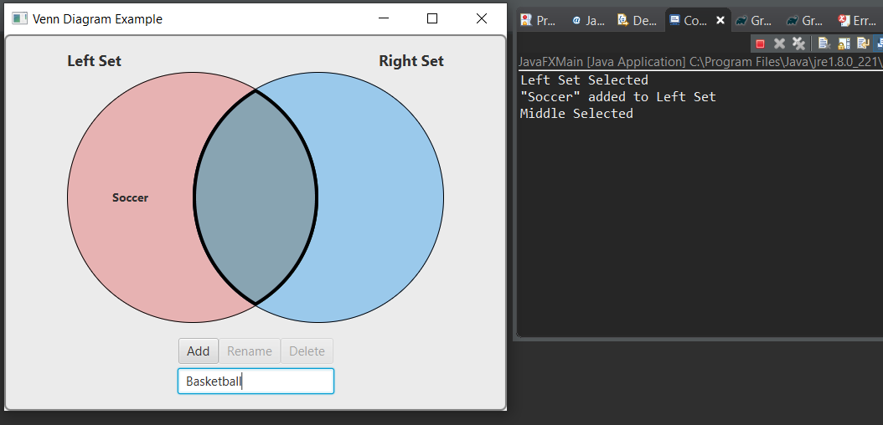

1. Click on the right set to add to it by typing in the textbox below and clicking on ‘Add’ when you are done.

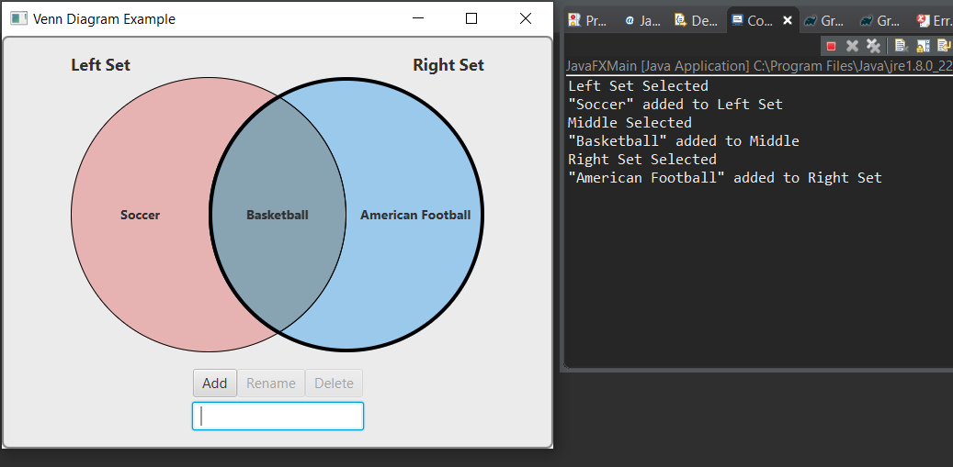

1. To rename the currently-selected set, select the set you want to rename, type the new name into the textbox, then click “Rename”.

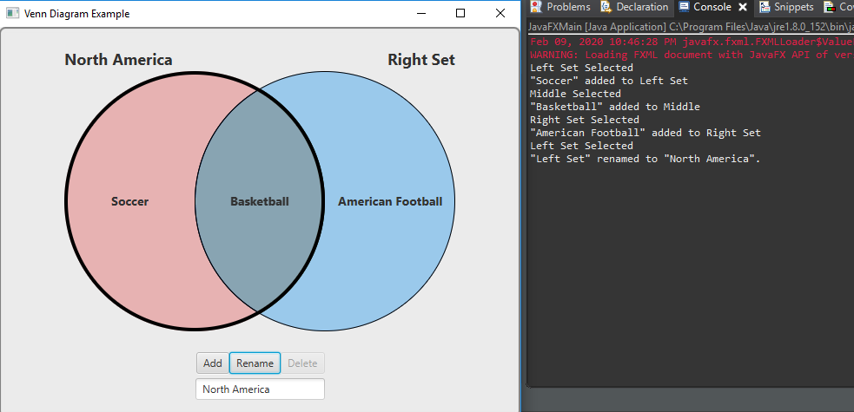

1. To remove the bold line of the selected circle, click anywhere on the whitespace outside the circles. That circle will remain selected in regards to the “Add” and “Rename” buttons.

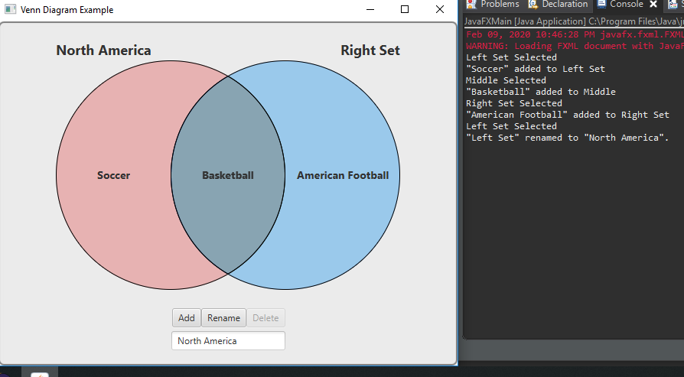

1. To rename a set, you can right click on that set. Once you have right clicked on it, a list of two options appear on your right, click on “Rename” to change the name of that set to anything. A window pops up where you can type into a textbox, and click on “Ok” once you are done renaming the set. The Customize function does not currently work.

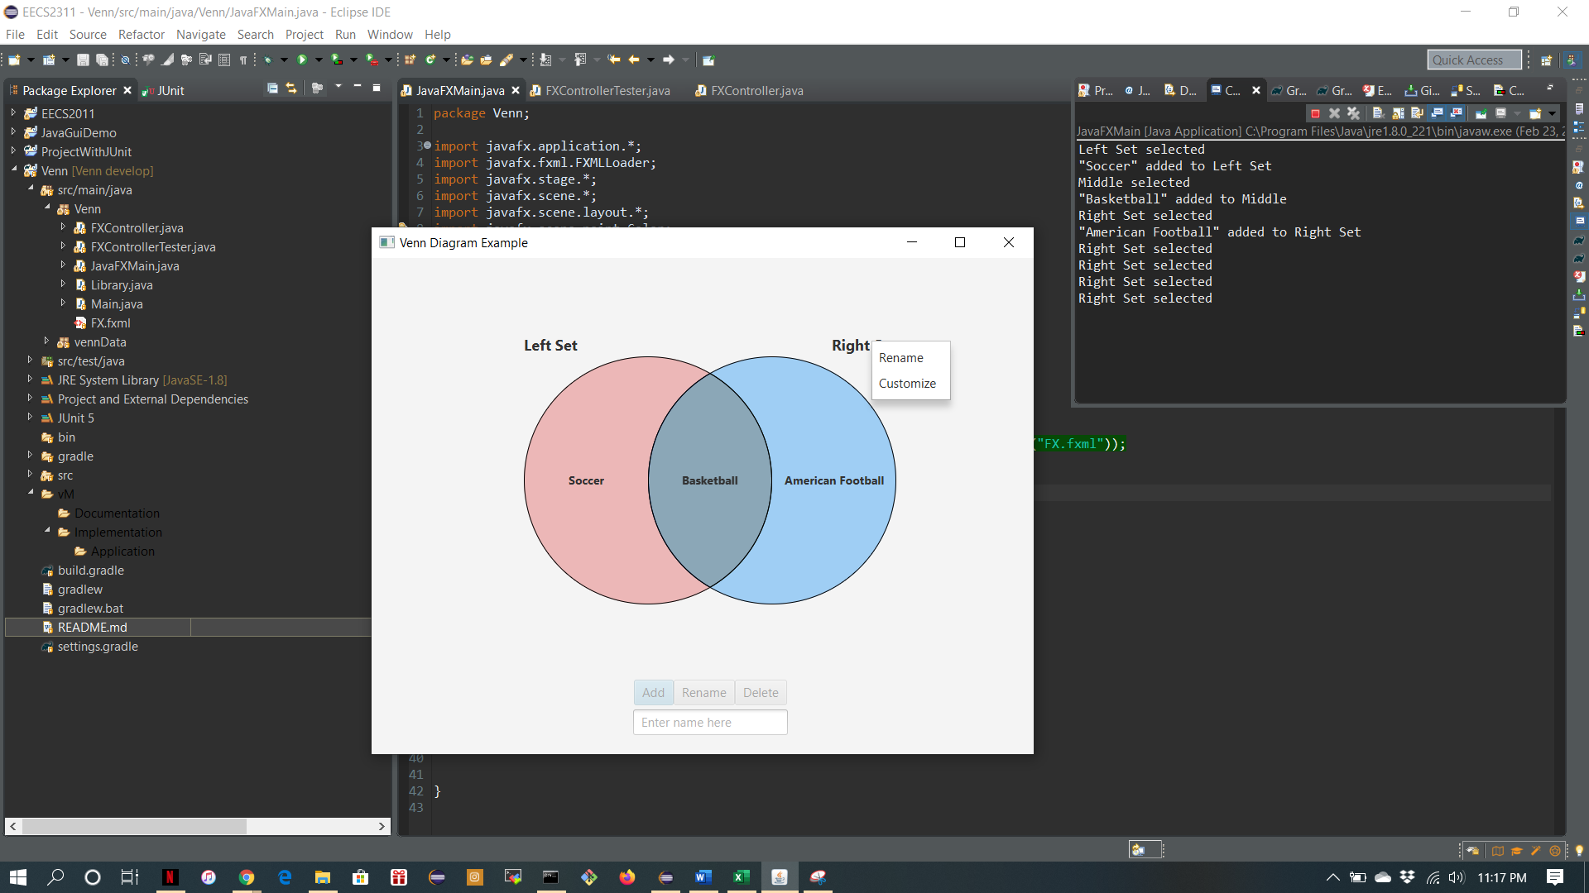

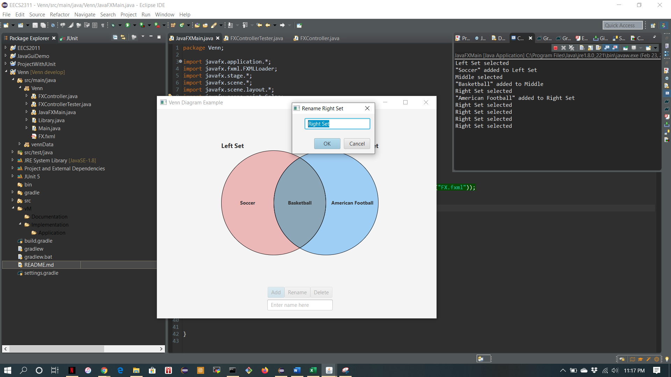

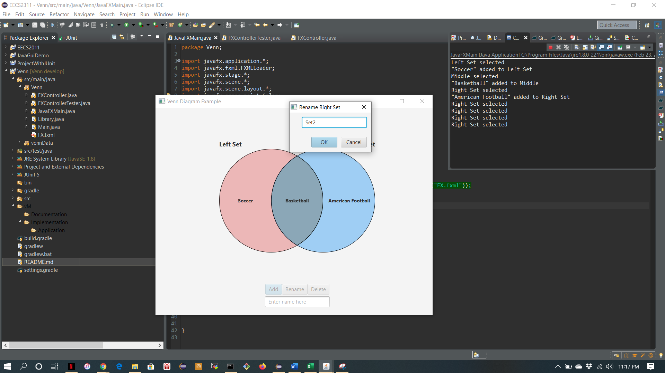

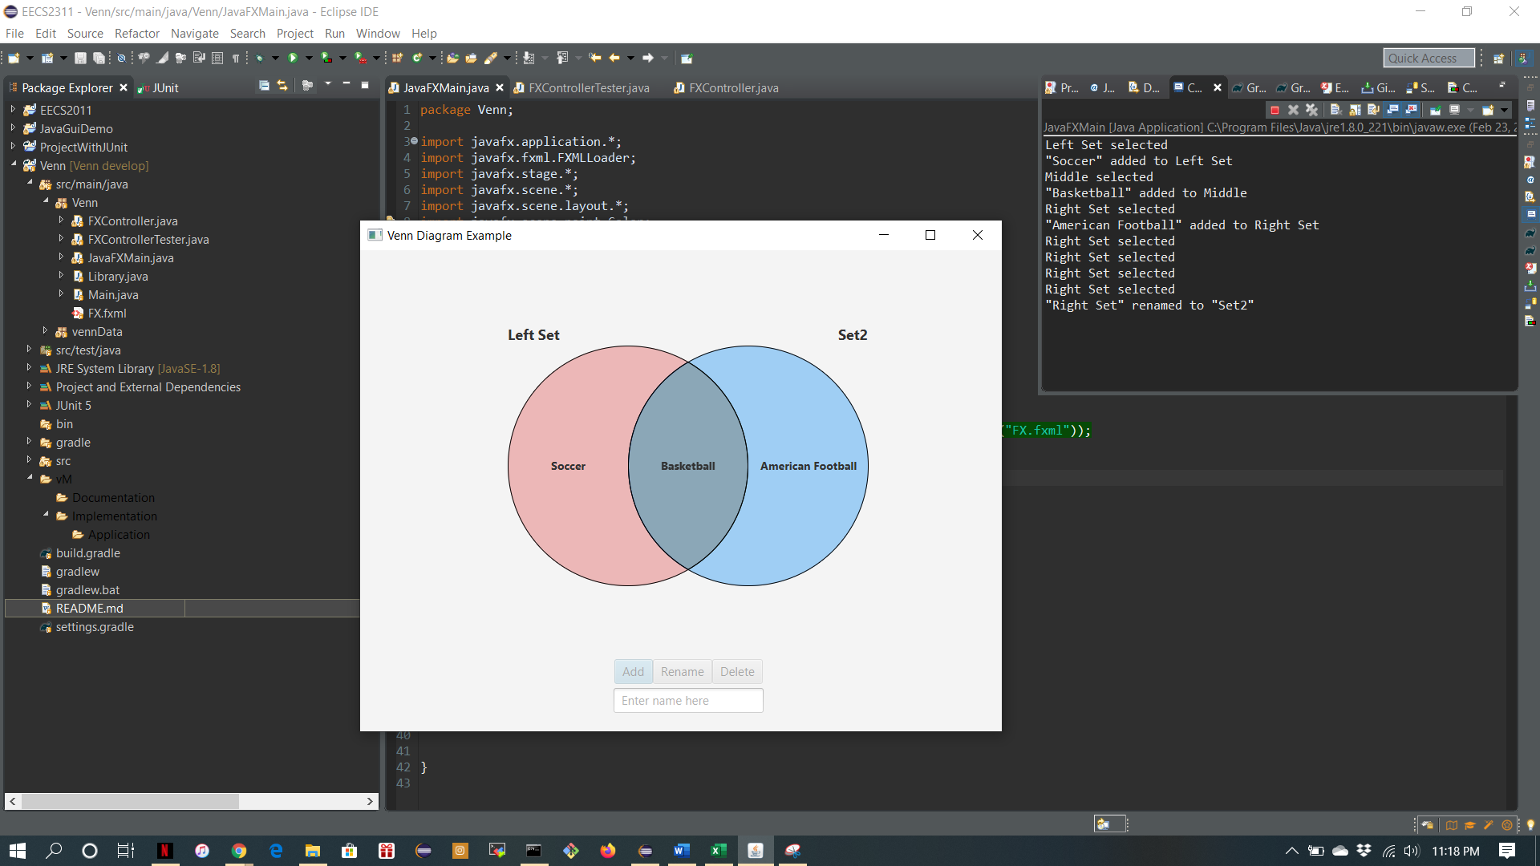

1. To remove an element from a set, go to whichever set the element is in and right click on that element, a list of options appear on your right, click on Rename to edit it. A different window will pop up with a textbox to write in, once you are done click “Ok”. The element is now renamed and edited. If you want to completely get rid of that element, you can click on “Delete” and a window will pop up asking you if you are sure you want to get rid of that element, click “Yes” and the element gets deleted.

